# Linking procedure between REMES:EU and the openENTRANCE scenario platform

The data download is facilitated by a Python script automatically connecting to the platform and downloading an Excel sheet containing the data.

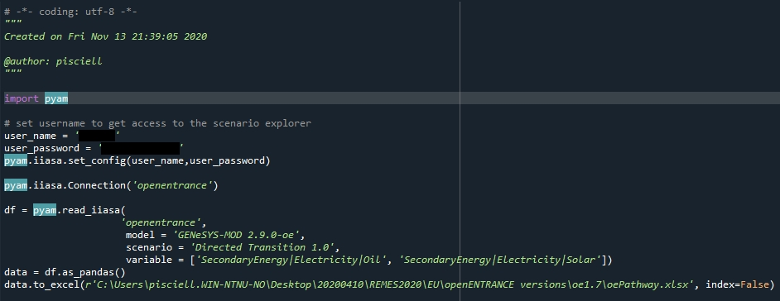

Once the data is downloaded, the excel file is read by a code snippet in the data handling section of the model

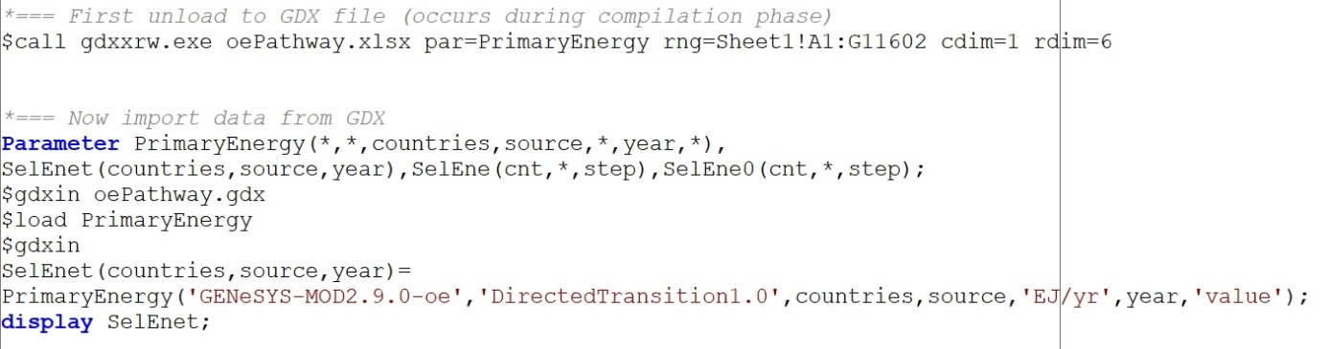

The data is then handled to turn it into suitable shares that can be applied to the definition of the shares in REMES:EU. In order to do this, the necessary mappings are applied to the downloaded data with the REMES indices.

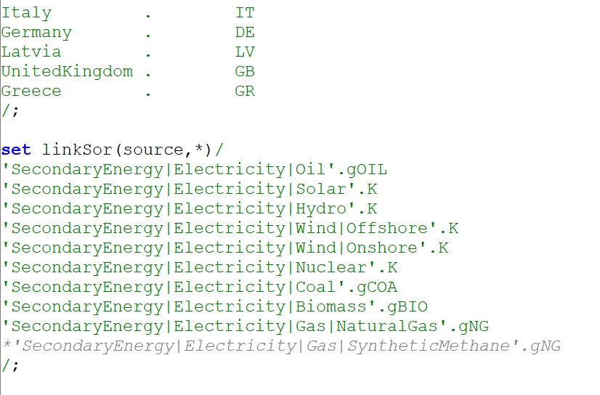

Once the mappings are established, the external data is transformed into understandable information for REMES:EU. This is done by redefining the shares obtained from the external data into shares that are compatible with the initial information featured into the Social Accounting Matrix, which is the main input used in REMES:EU. The data is then used in the model.

Once the model simulation is terminated, the results are converted into the IAMC format using the following code snippet in GAMS, which creates a csv file that is then uploaded into the Platform.

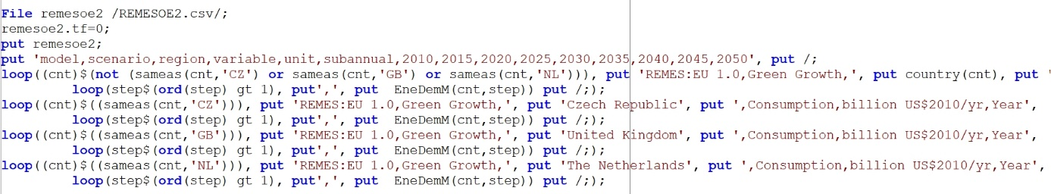

This creates a csv file in the IAMC format. The output provided by GAMS features blank spaces before and after every string, which makes the output not suitable for the Scenario Platform. To solve this issue, a dedicated VBA routine has been developed in an Excel spreadsheet. The output is now accepted by the Scenario Platform. After following the instructions provided in the Guideline to Use the OpenENTRANCE database, the data file is uploaded into the Scenario Explorer. The following snapshot is taken directly on the data loaded on the Scenario Explorer.

